TRADE PRICELIST

OCTOBER 2008
EXCLUSIVE OF VAT

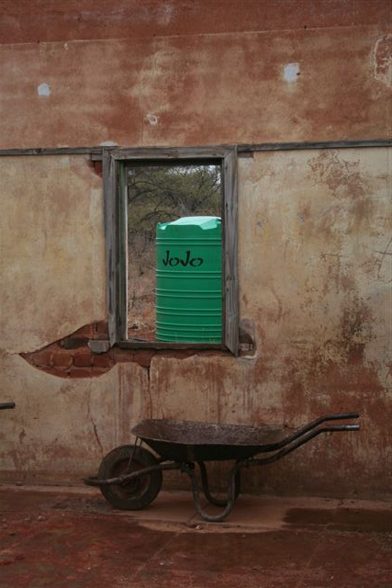

VERTICAL TANKS

TANK | TYPE | DIAMETER | HEIGHT | SG | PRICE
260-Liter | Water  Medium | 640 mm | 850 mm | 1.0  1.4
500-liter | Water  Chemical Medium  Chemical Heavy | 825 mm | 1 085 mm | 1.0  1.4  1.6
1 000-Liter | Water  Chemical Medium  Chemical Heavy | 1 100 mm | 1 200 mm | 1.0  1.4  1.6
1 500-Liter | Water  Chemical Medium  Chemical Heavy | 1 210 mm | 1 600 mm | 1.0  1.4  1.6
2 200-Liter | Value tank | 1 420 mm | 1 600mm | 1.0
2 500-Liter | Water  Chemical Medium  Chemical Heavy | 1 420 mm | 1 800 mm | 1.0  1.4  1.6
5 000-Liter | Water  Chemical Medium  Chemical Heavy | 1 800 mm | 2 200 mm | 1.0  1.4  1.6
10 000-Liter | Water  Chemical Medium  Chemical Heavy | 2 200 mm | 3 040 mm | 1.0  1.4  1.6
15 000-Liter | Water  Chemical Medium  Chemical Heavy | 2 600 mm | 3 450 mm | 1.0  1.4  1.6
20 000-Liter | Water  Chemical Medium  Chemical Heavy | 2 600 mm | 4 200 mm | 1.0  1.4  1.6

HORIZONTAL TANKS

TANK | HEIGHT | LENGTH | WIDTH | SG | PRICE | PRODUCT
220-Liter  Planter type | 590 mm Diameter | 1 070 mm | - | 1.4 |  | 
500-Liter | 800 mm | 1 270 mm | 800 mm | 1.4
900-Liter | 820 mm | 1 450 mm | 940 mm | 1.4 |  | 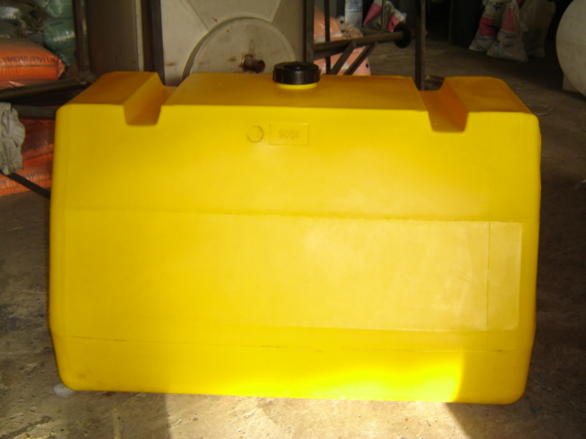
1 000-Liter | 950 mm | 1 560 mm | 1 100 mm | 1.4
1 500-Liter | 1 400mm | 1 900 | 1 130 | 1.4 |  | (ROUND, AS BELOW)
2 500-Liter | 1 120 mm | 1 950 mm | 1 630 mm | 1.4 |  | 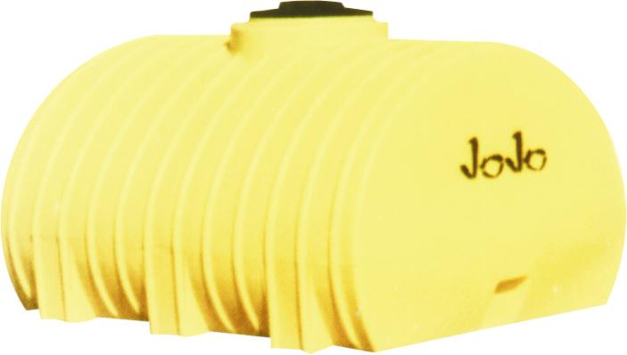
5 000-Liter | 1 450 mm | 2 370 mm | 2 100 mm | 1.0  1.4 |  | 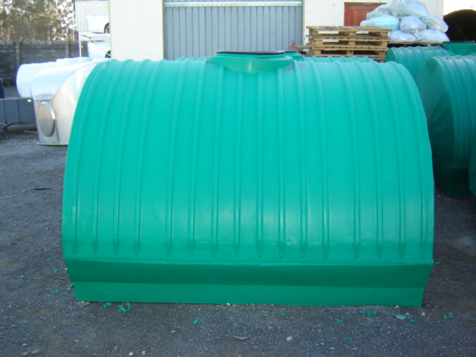
LOW PROFILE TANKS

6 000-Liter LP | 1 850 mm | 2 200 mm  Diameter | - | 1.0  1.4  1.6 |  | 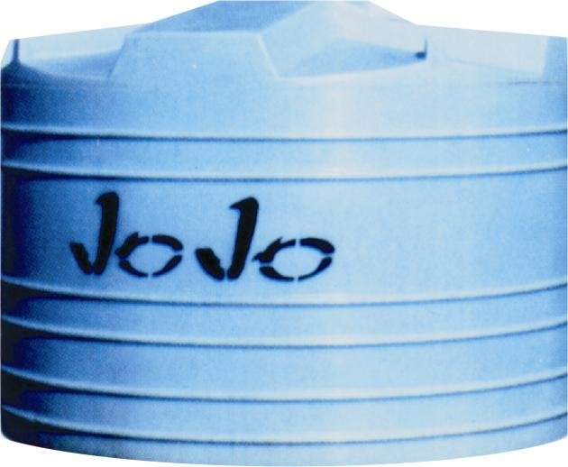

OLIVE TANKS

TANK | HEIGHT | DIAMETER | WEIGHT | SG | PRICE
1 400L | 1 670mm | 1 090mm | 40kg | 1.4
5 600L | 2 000mm | 2 200mm | 145kg | 1.4

SANITATION

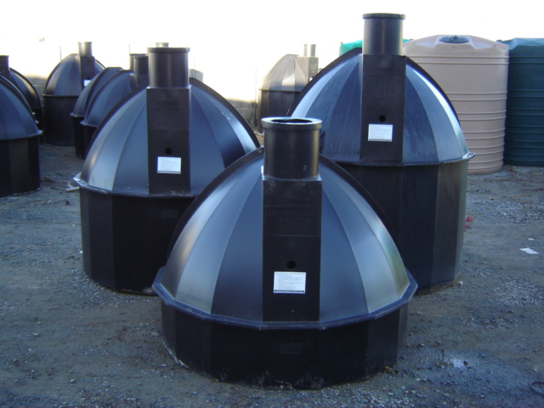

PERSONS | MODEL | DIAMETER | HEIGHT | LID | PRICE
(2 – 4) | 1 250-liter | 1 660 mm | 1 480 mm | 290 mm
(2 – 5) | 1 500-liter | 1 660 mm | 1 680 mm | 290 mm
(4 – 6) | 1 750-liter | 1 660 mm | 1 580 mm | 290 mm
(4 – 7) | 2 000-liter | 1 660 mm | 1 700 mm | 290 mm
(4 – 9) | 2 500-liter | 1 660 mm | 1 960 mm | 290 mm

Heavy Duty Septic/Conservancy Tank (Brown)
(2 – 4) | 1 250-liter | 1 660 mm | 1 480 mm | 290 mm
(2 – 5) | 1 500-liter | 1 660 mm | 1 680 mm | 290 mm
(4 – 6) | 1 750-liter | 1 660 mm | 1 580 mm | 290 mm
(4 – 7) | 2 000-liter | 1 660 mm | 1 700 mm | 290 mm
(4 – 9) | 2 500-liter | 1 660 mm | 1 960 mm | 290 mm

Additional information:
- Polyethylene product
- Chemical resistant
- UV stabilized material
- Outlet pipe-50mm
- Inlet pipe-110mm
- Sewage only
- Installation instructions provided

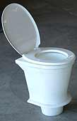 | PRODUCT : PIT PEDESTAL - VIP 200  Price :
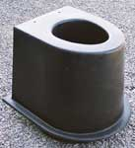 | PRODUCT : PIT PEDESTAL - VIP 450  Price : Special quote
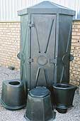 | PRODUCT : TOILET HUT - Hexagonal  (Shell only)  Price :
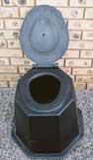 | PRODUCT : PIT PEDESTAL – (PP30)  Price :
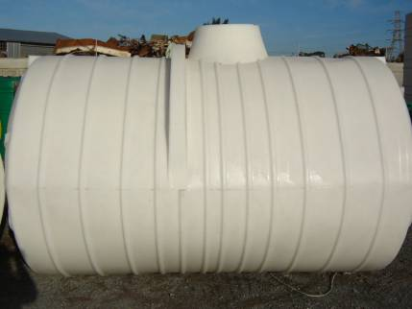 | PRODUCT : 6 000L CONSERVANCY TANK  Diameter – 1 791mm  Length – 3 051mm  Manhole – 450mm  Weight – 225kg  Price (Conservancy) : With septic tank fittings :
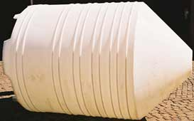 | PRODUCT : SILO TANK  SPECIFICATIONS  300-Liter Price :  1 200-Liter Price :  5 000-Liter Price : 17 000-Liter Price : Special quote
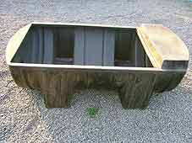 | PRODUCT : WATER TROUGH 250  (Ball-valve not included)  SPECIFICATIONS  250-Liter  HEIGHT : 550 mm  WIDTH : 400 mm  LENGTH : 1 300 mm  Price :
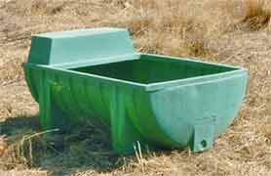 | PRODUCT : WATER TROUGH 500  (Ball-valve not included)  SPECIFICATIONS  500-Liter  HEIGHT : 500 mm  WIDTH : 990 mm  LENGTH : 1 560 mm  Price : R985.00
PRODUCT : WATER TROUGH 160

SPECIFICATIONS
160-Liter
HEIGHT : 160 mm
TOTAL HEIGHT : 370 mm
WIDTH ABOVE : 400 mm
WIDTH BELOW : 250 mm
LENGTH : 2 100 mm
Price : R620.00
PRODUCT : 26L DAY OLD OSTRICH TROUGH

Price : R250.00

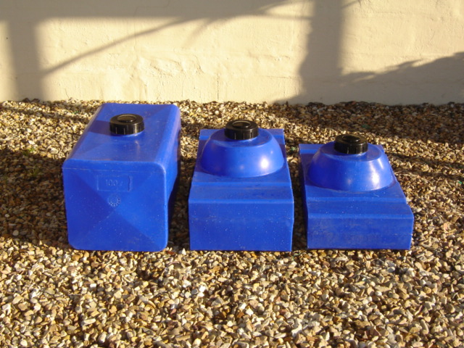 | PRODUCT : OUTDOOR/MOTORBIKE TANK  (FOUR WHEELER)  50L : 75L  100L :
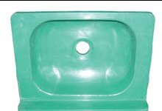 | PRODUCT : WASH BASIN  Price :
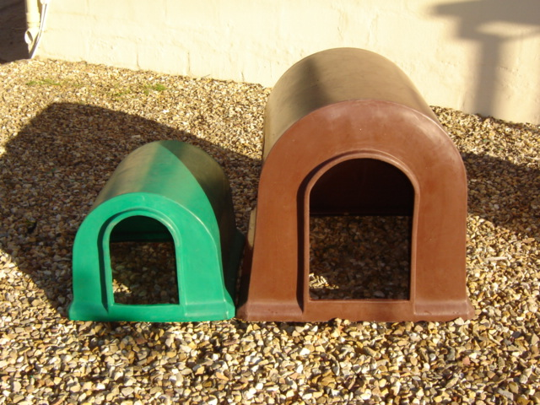 | PRODUCT : DOG KENNEL  SMALL Price :  LARGE Price :
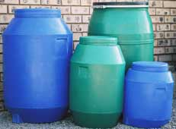 | PRODUCT : CLIP-ON-LID DRUM  SPECIFICATIONS  100-Liter Price :  210-Liter Price : PRODUCT : SCREW-ON-LID DRUM  SPECIFICATIONS  50-Liter Price :  90-Liter Price :  210-Liter Price :

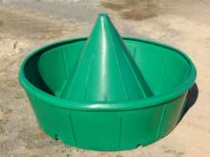 | PRODUCT : 1600L DRINKING TROUGH  SPECIFICATIONS  1600-Liter  Height – 580mm  Diameter – 2 050mm  Weight:  Trough – 50kg  Cone - 17kg  Price :

ACCESSORIES:

Tank connectors (STD BLACK)  Product: Price: |  |  | Lids  Size Price: |  |  | Other  Product: | Price:
40mm | R20.00 |  | 125mm | R90.80 |  | Brass tank tap (Bib tap)
50/40mm (Bush) | R6.00 |  | 250mm | R100.00 |  | 20mm Plastic Tap
40/20mm (Reducer) | R6.00 |  | 450mm | R155.50 |  | Stockman’s valve
40/20mm (Stopper) | R6.00 |  | TL480mm | R 46.30 |  | Standard Toilet Seat  (For VIP 200)

TANK CONNECTORS (GREY):
Product: Price:
15mm Tank Connector
25mm Tank Connector
40mm Tank Connector
40/25mm Tank connector with Diesel Seal
50mm Tank Connector - Standard
50mm Tank Connector – Long Thread
50mm Tank Connector – Elbow
75mm Tank Connector

